Postnatal Exercises-(NHS guidelines)

Dr Harsha Jain

Pelvic floor muscles
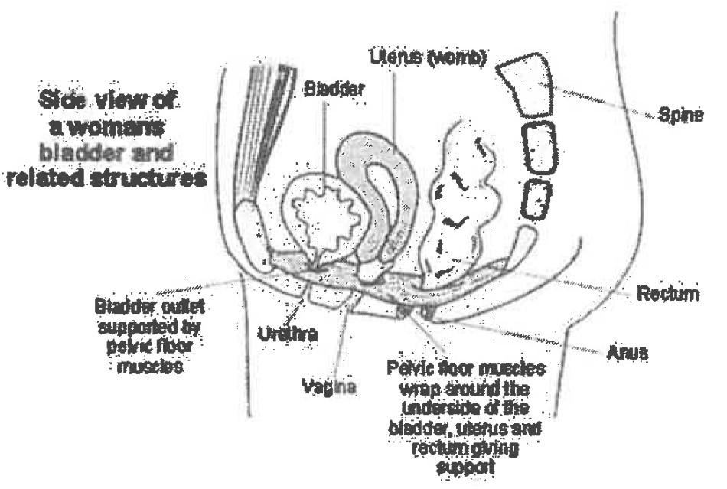
Pelvic floor muscles act like a 'hammock' supporting your bladder and other internal organs from dropping down (prolapse). They also help control bladder and bowel function and prevent leakage of urine, wind or faeces.

It is important for you to practice pelvic floor exercises because during pregnancy these muscles become weakened from the weight of your baby bearing down. In a vaginal delivery these muscles stretch and weaken further as the baby passes through the pelvis.

There are two types of muscle fibre in the pelvic floor: the fast twitch fibres contract quickly to prevent leakage when coughing, laughing and sneezing; the slow twitch provide constant tone to support you through day and night.
—-------------------------------------------------------

Exercise 1: Pelvic Floor

Strengthening the ‘slow' twitch fibers
- Squeeze the muscles around your back passage as if stopping yourself passing wind.
- Then lift the muscles up inside as if stopping yourself passing urine.
- Now hold. Initially you may only manage to hold for 2 seconds, but as you practice and get stronger the aim is to reach 1 O seconds.
- Repeat 10 times.

Strengthening the ‘fast’ twitch fibers
- Squeeze and lift the muscles as above, as strong and fast as you can. Then relax.
- See how many you can do. The aim is to manage 10, initially you may reach 4 or 5 before
- the muscle tires, the muscle will get stronger with practice.
- If this is uncomfortable initially then do a gentle lift and let go, repeating 10 times.

Do not hold your breath, use your stomach muscles or buttocks.
No one should be able to see you exercising, so you can practice them whenever and wherever you like…We recommend you try to fit the exercises into your daily routine, for example every time you feed your baby. It may help to set an alarm on your phone or use a pelvic floor phone app like the "Squeezy App" to remind you. http://www.squeezj:'.app.eo.uk/index.html

You should exercise your pelvic floor at least three times a day.
You need to strengthen your pelvic floor muscles in different positions; lying down, in sitting, standing up and walking.
To prevent leakage, tighten these muscles before activities which put pressure on the pelvic floor for example when coughing, sneezing or picking up your baby.
--------------------------------------------

Tummy muscles

The following exercises will help strengthen and tone your abdominal muscles, to help protect your spine and maintain a good posture.

Repeat each exercise 10 times, 3 x a day.

Exercise 2: Deep abdominal muscles

Lay on your back with your knees bent and head supported.

- Place your hands on your stomach below your belly button. Breathe in through your nose, breathe out gently through your mouth and gently draw your stomach In away from your hands towards your back.
- Keep your stomach pulled in. The aim is to hold for 10 seconds (or 3 breath cycles).
- Progress to do this exercise in sitting and standing.
- Use these deep abdominal muscles when doing activities that require effort such as lifting your baby.

Exercise 2 forms the base for the following exercises.

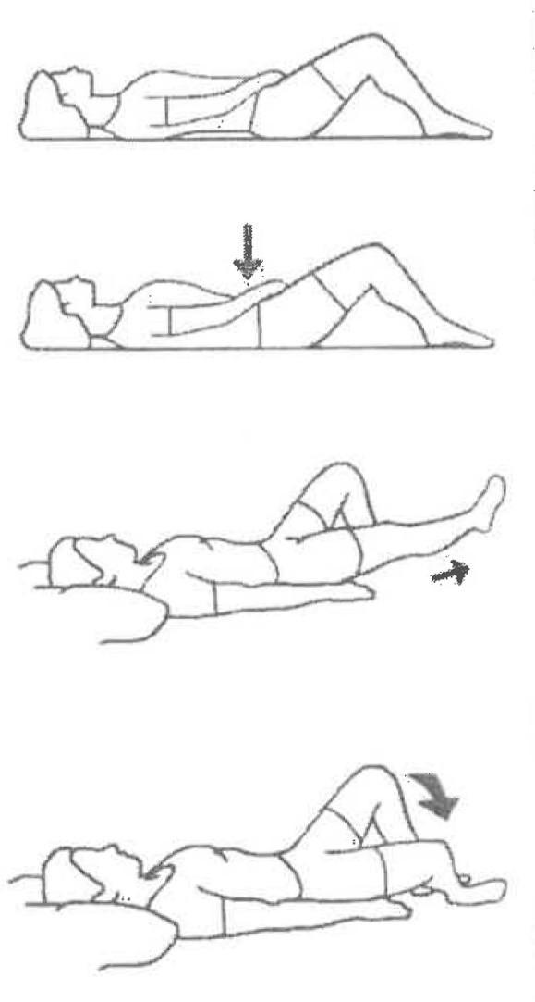
Exercise 3: Pelvic Tilt
- Lie on your back with your knees bent.
- Pull in your stomach, tighten your pelvic floor muscles and tilt your pelvis by gently flattening your back into the bed. Hold for 3- 5 seconds breathing normally, then relax.
- Progress by trying different positions such as sitting, standing, side lying.

Exercise 4: Leg slides.
- Lie on your back with your knees bent, pull in your stomach and tighten your pelvic floor muscles.
- Gently slide one leg out straight and return.
- Repeat with other leg.

Exercise 5: Single knee fall out
- Lie on your back with your knees bent, pull in your stomach and tighten your pelvic floor muscles.
- Keeping your pelvis still and stomach pulled in, allow one knee to slowly drop out to the side.
- Slowly bring your knee back to the middle.
- Repeat with the other leg.

Exercise 6: Knee bends

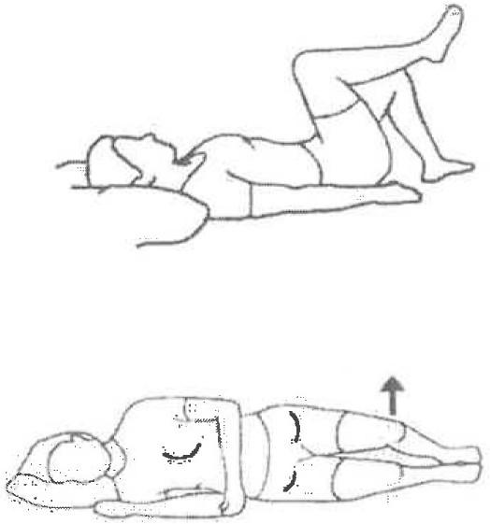
- Lie on your back with your knees bent, pull in your stomach and tighten your pelvic floor muscles.
- Slowly lift one leg up off the bed keeping your knee bent.
- Hold for 10 seconds, then slowly return to the starting position
- Repeat with the other leg.

Exercise 7: Clam
- Lie on your side with knees bent and feet together, pull in your stomach and tighten your pelvic floor muscles.
- Lift your top leg moving your knees apart but keeping your feet together, keep your pelvis still throughout.
- Hold for 5 seconds then slowly return to the starting position.
- Repeat with the other leg.

Exercise 8: Tummy Flattener for separation of stomach muscles
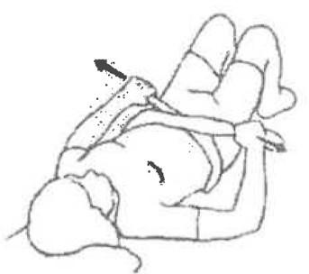
  - Lie on your back with your knees bent
  - Wrap a scarf around your waist crossed over the stomach
  - As you breathe out, raise your head up whilst pulling the ends of the scarf to support your stomach muscles into the middle. Alternatively you can do this without a scarf by supporting the muscles with your hands.
  - Return to lying flat.

For further Discussions , take appointment -www.drharshajain.in,

